GitHub Push Demonstration

By Xuzhou Yin

1. Create a repository in GitHub, in this case, hBayesDM
2. Go to the directory where the directory will be stored locally (Probably some folder in D drive)
3. Then install git comments through terminal
   1. <https://git-scm.com/book/en/v2/Getting-Started-Installing-Git> (This website is about how to install git on Linux, Mac and Windows)
4. Navigate to the directory where the directory will be stored locally through terminal (cd <absolute path to that folder>)
5. Type ‘git init’ in terminal in order to initialize git
6. Go to the repository created in GitHub, find the button Clone or download as followed:

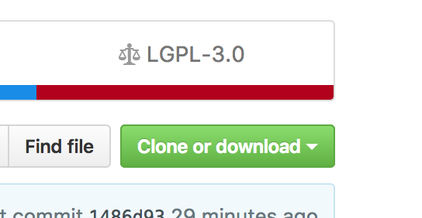

1. Click the button, and copy the links it displays
2. In terminal type ‘git clone <link copied from GitHub>’
3. Then it will automatically copy the repository to current directory as following image shows

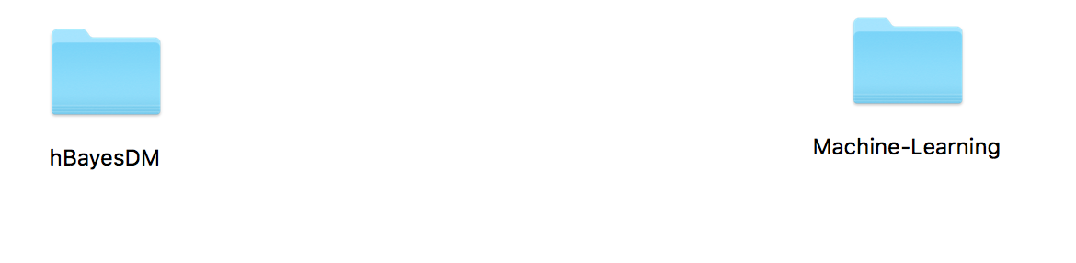

1. Then we can do whatever we want inside the repository locally (Such as drag file into the folder)
2. After finishing manipulating the files, go to terminal, type ‘git add --all’
3. Then type ‘git commit’ to commit previous changes
4. Finally, type ‘git push’ to push it to GitHub, it will ask for GitHub password and username
5. After that, we are done!